AGILE LAB CASE STUDY

23MIS0669
R.AJAYSHARAN

Use appropriate Git Commands to Execute the following case studies in VS Code

Case Study 1: New Project Version Control Setup

Scenario: You are assigned to develop a Library Management System. Before coding, your team decides to enable version control.

Tasks:
- Create a project folder and open it in VS Code
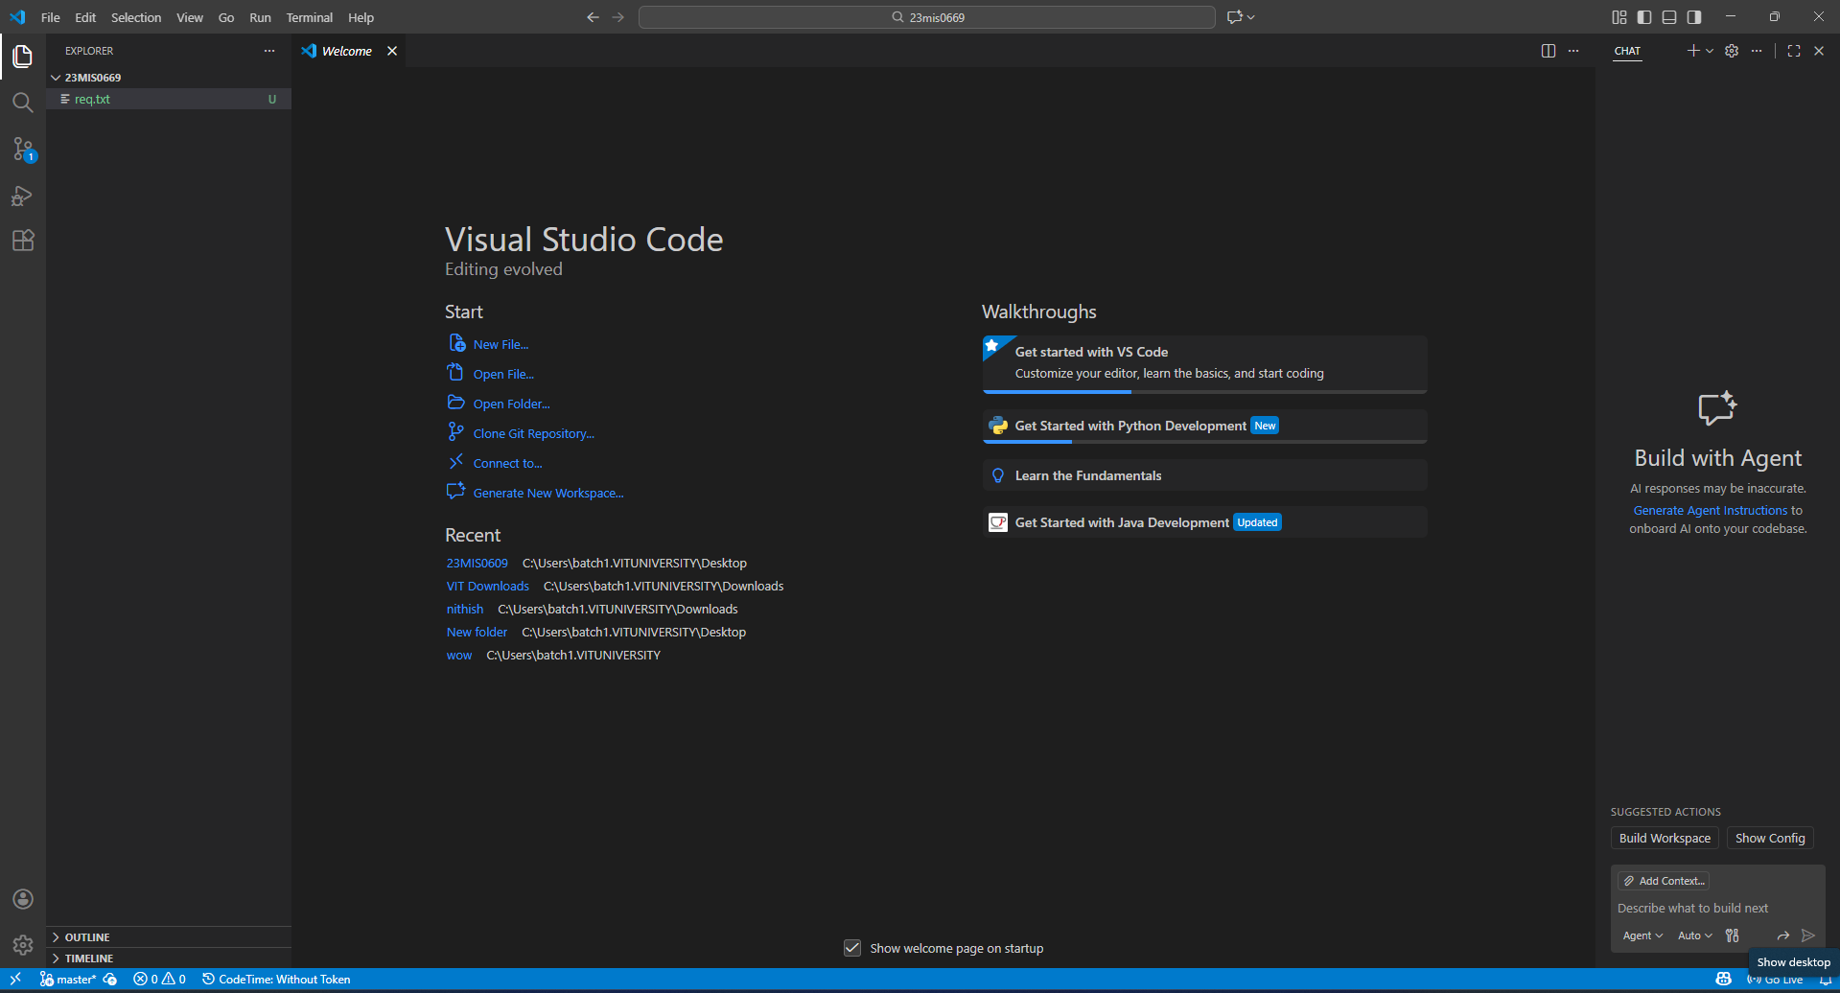

Initialize a Git repositor

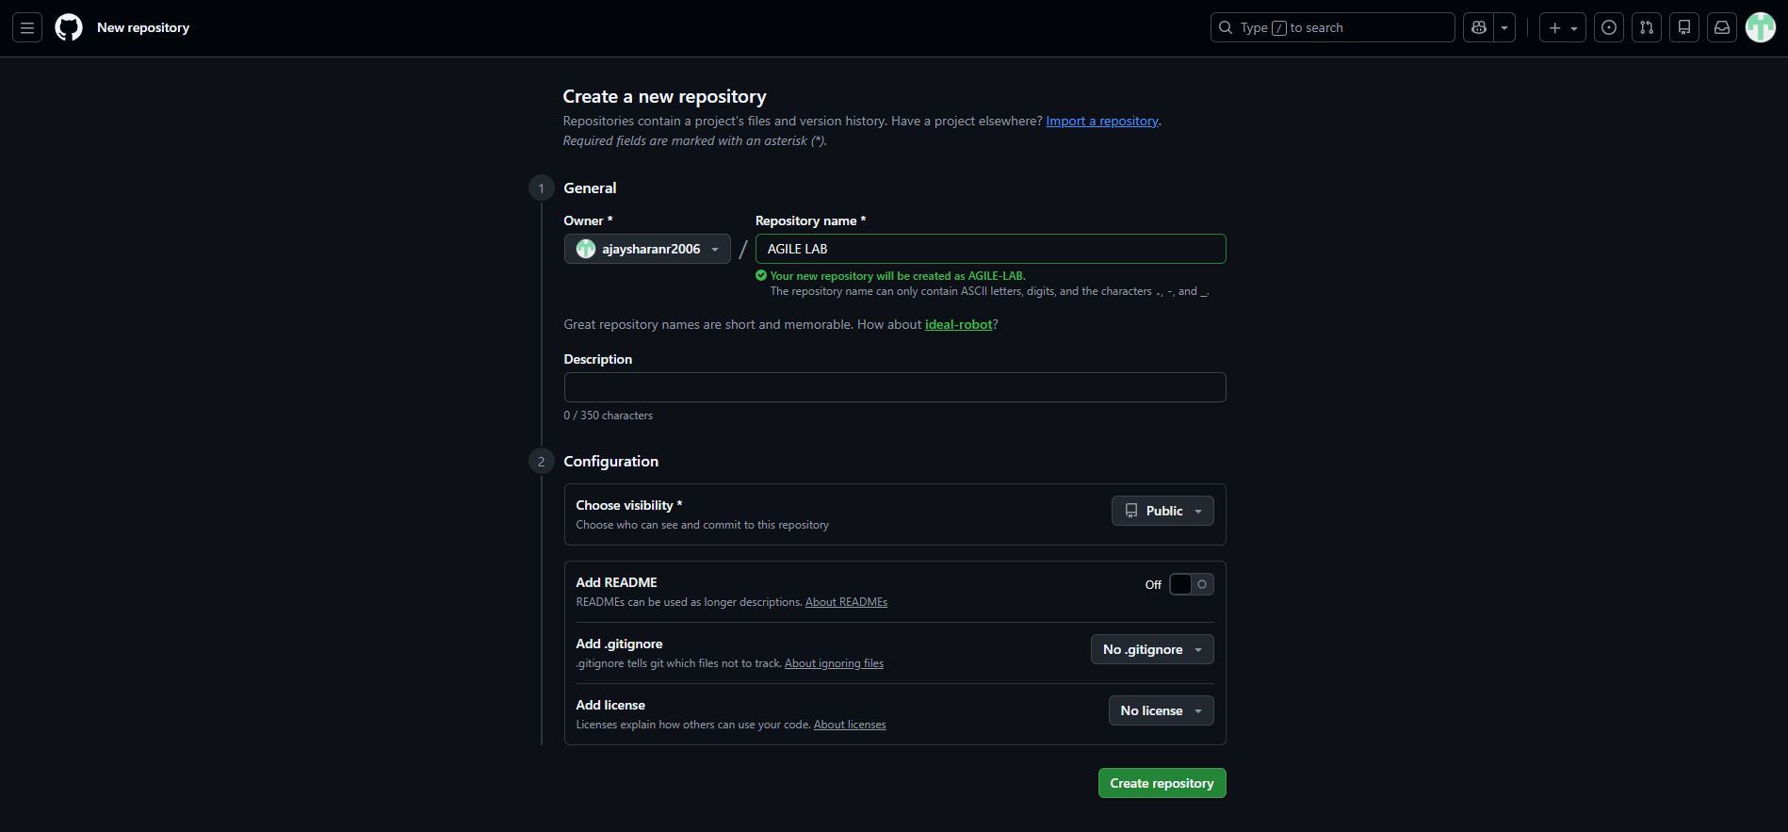
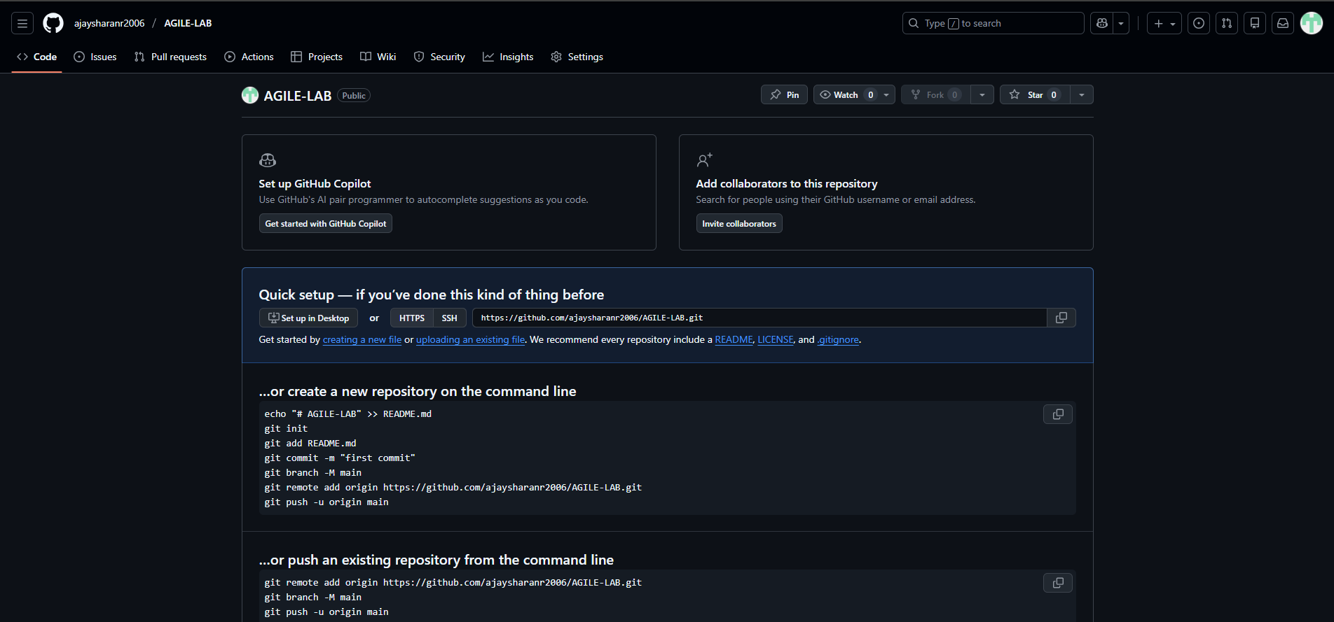

Create a Python file and track it using Git
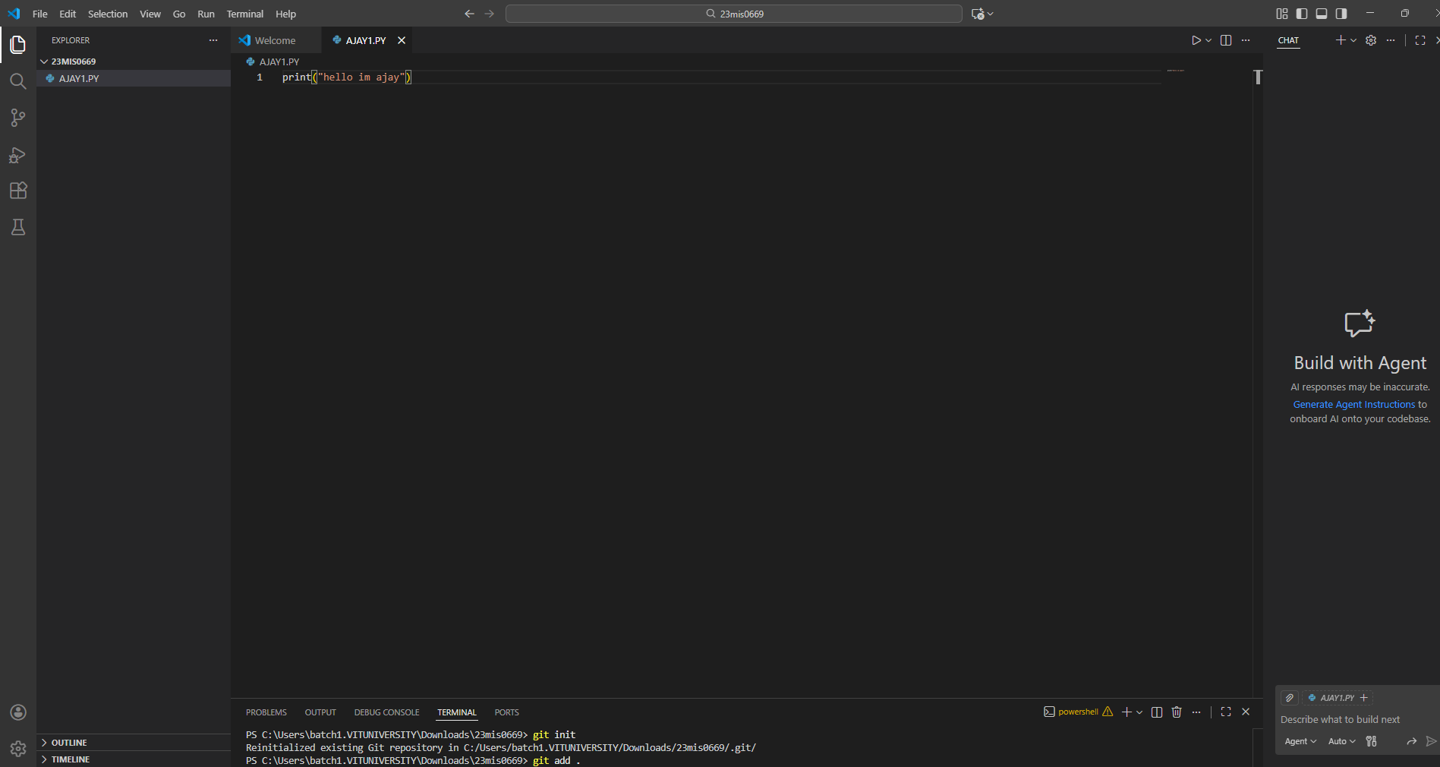

Commit the initial version
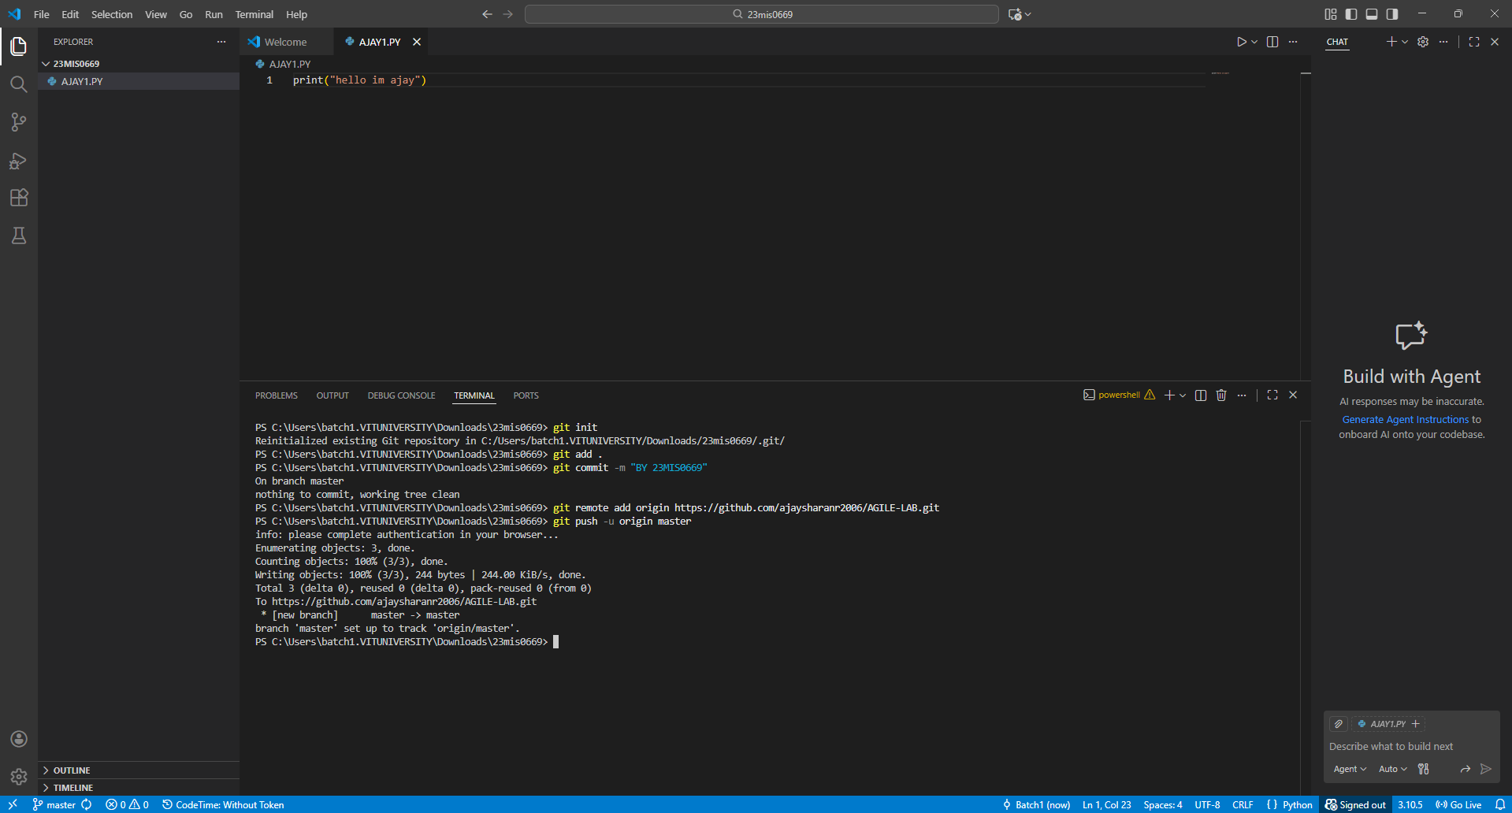

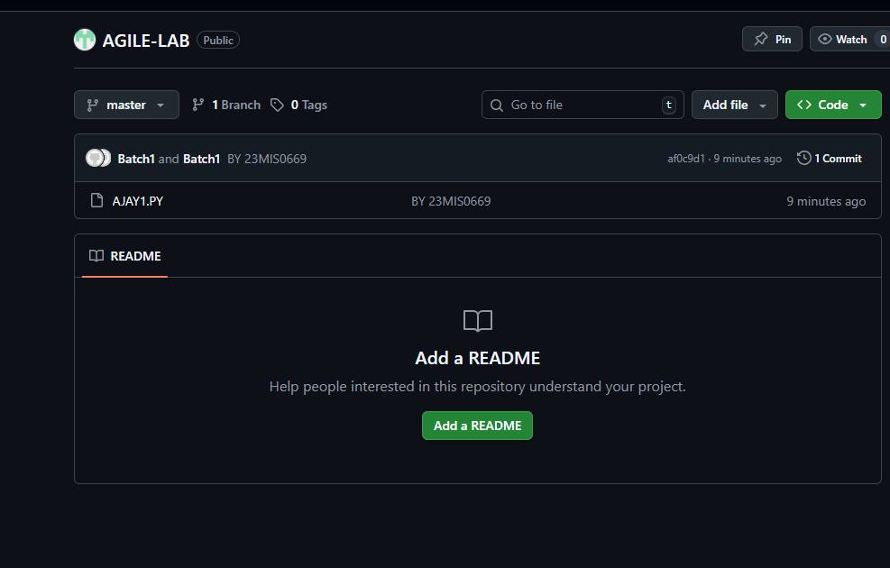
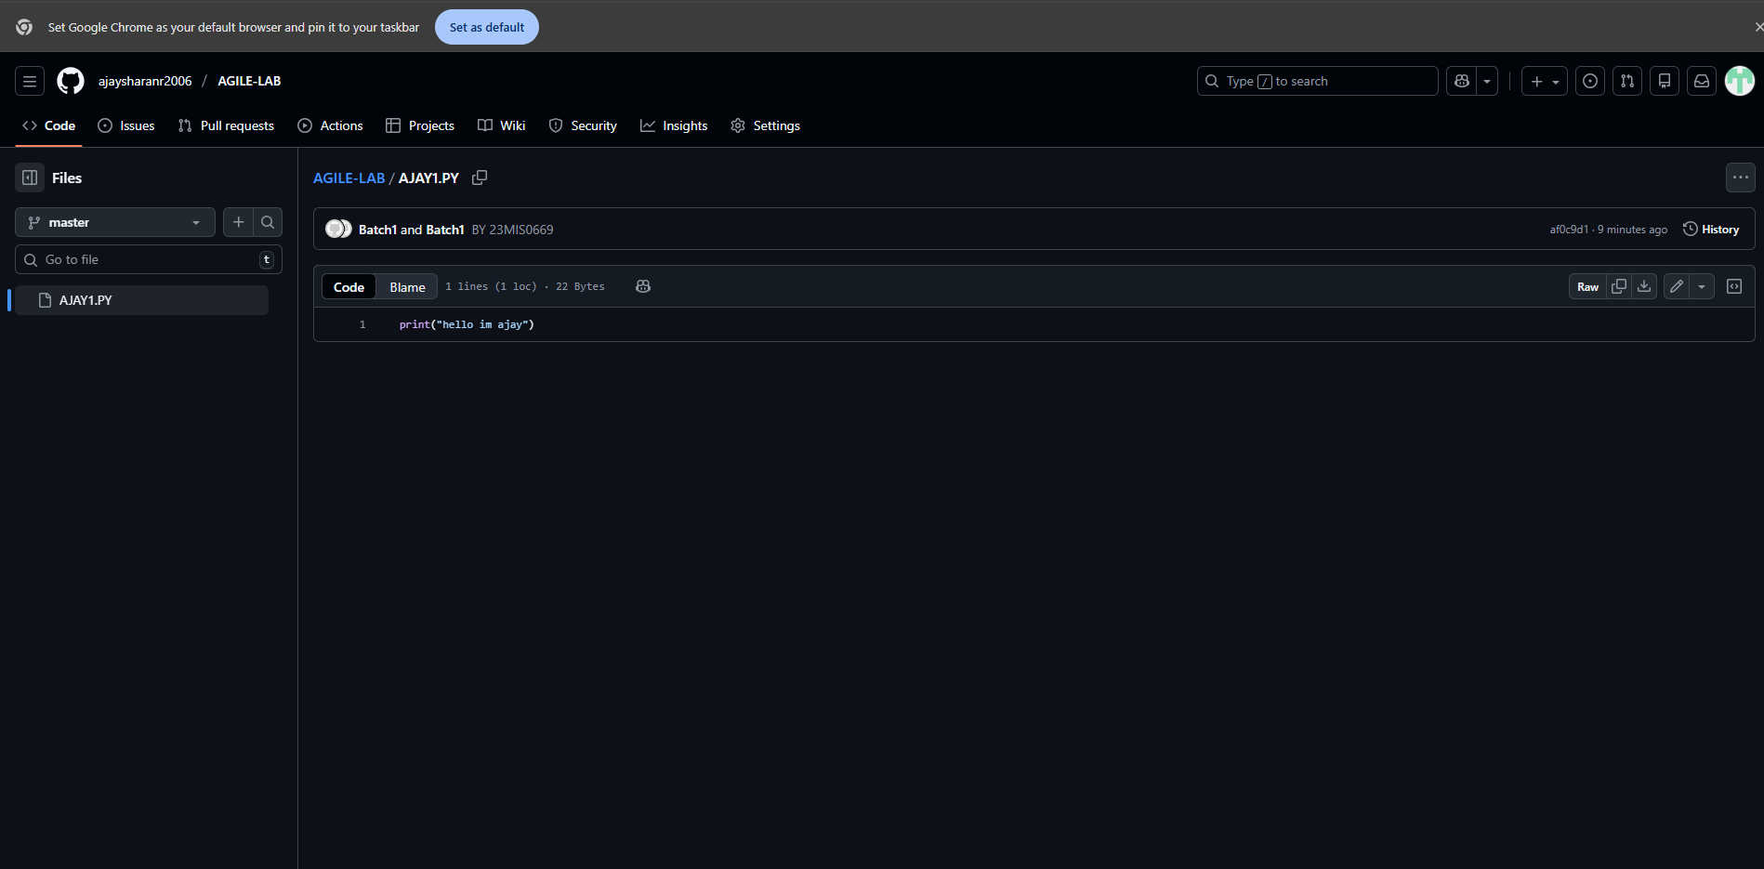

Case Study 2: Tracking Daily Code Changes

Scenario: You are working on a Student Registration Module. You make small updates daily and need to record them.

Tasks:

Modify an existing file
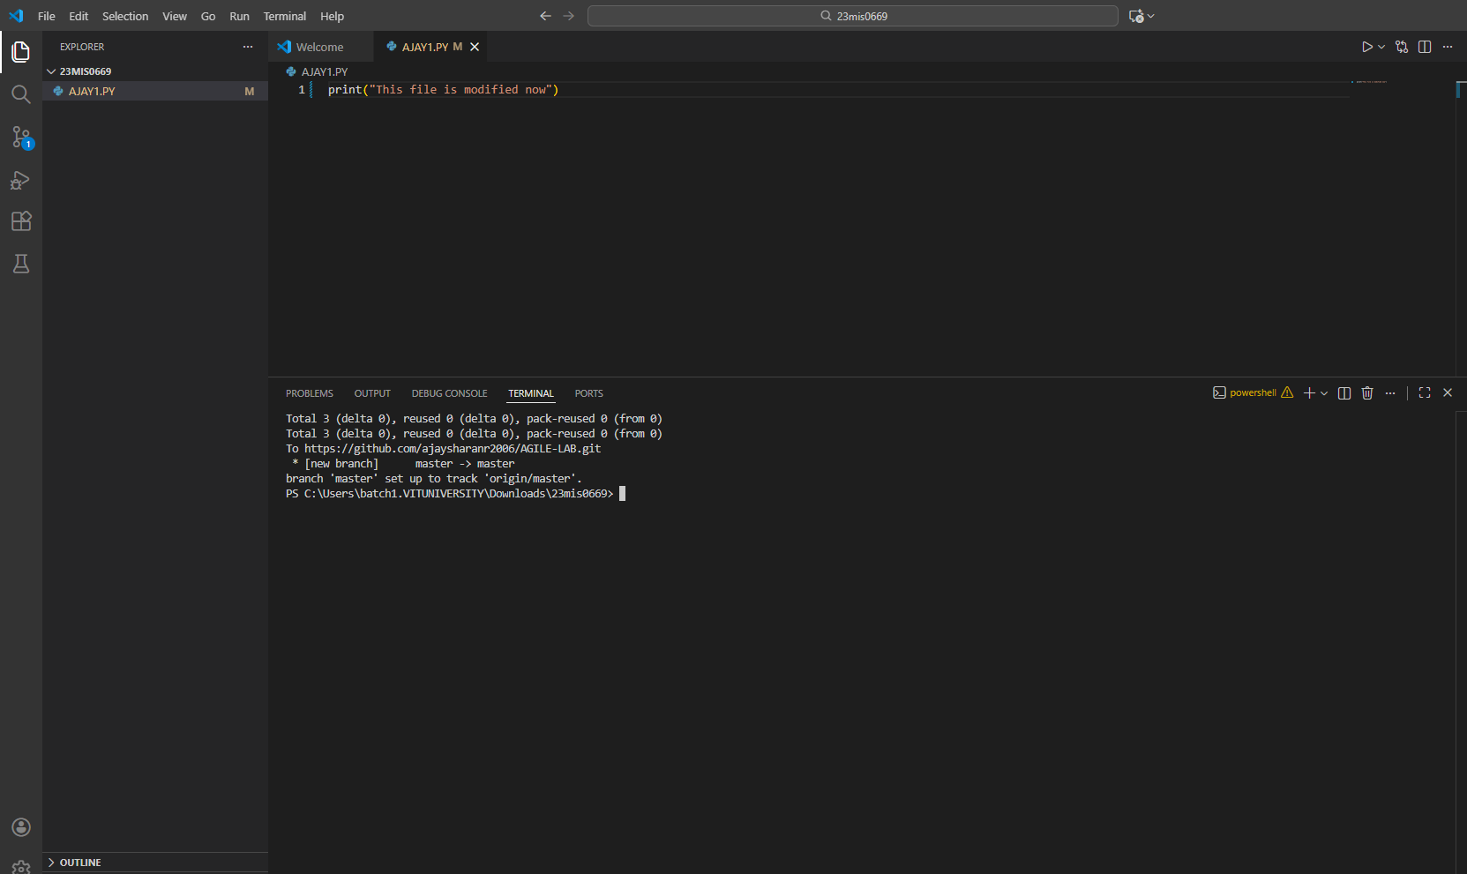

Check file differences

Stage and commit changes
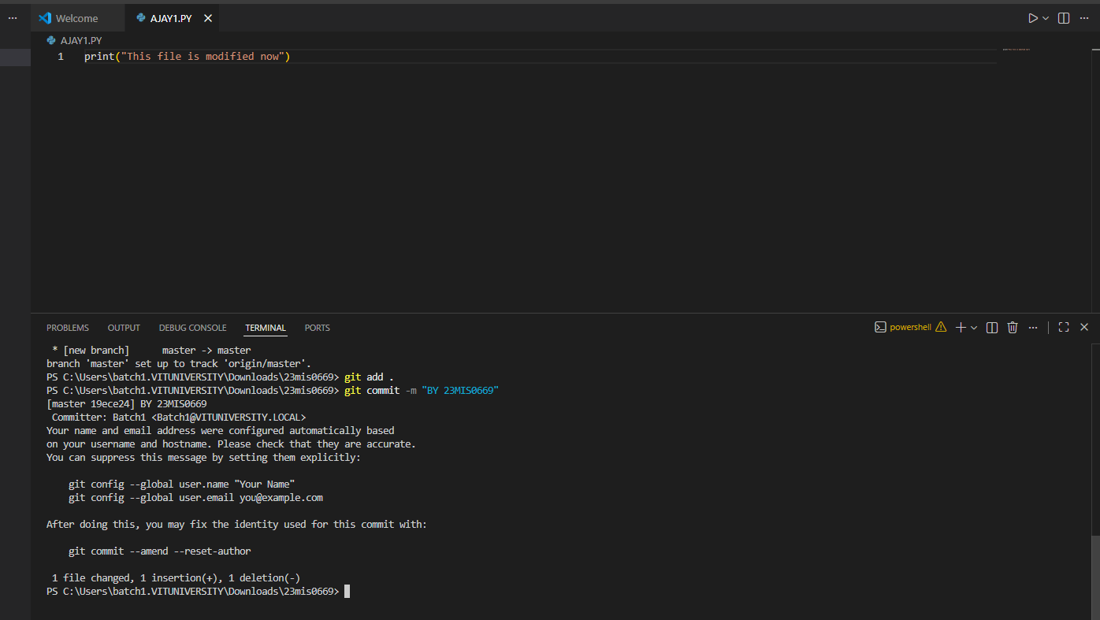

View commit history
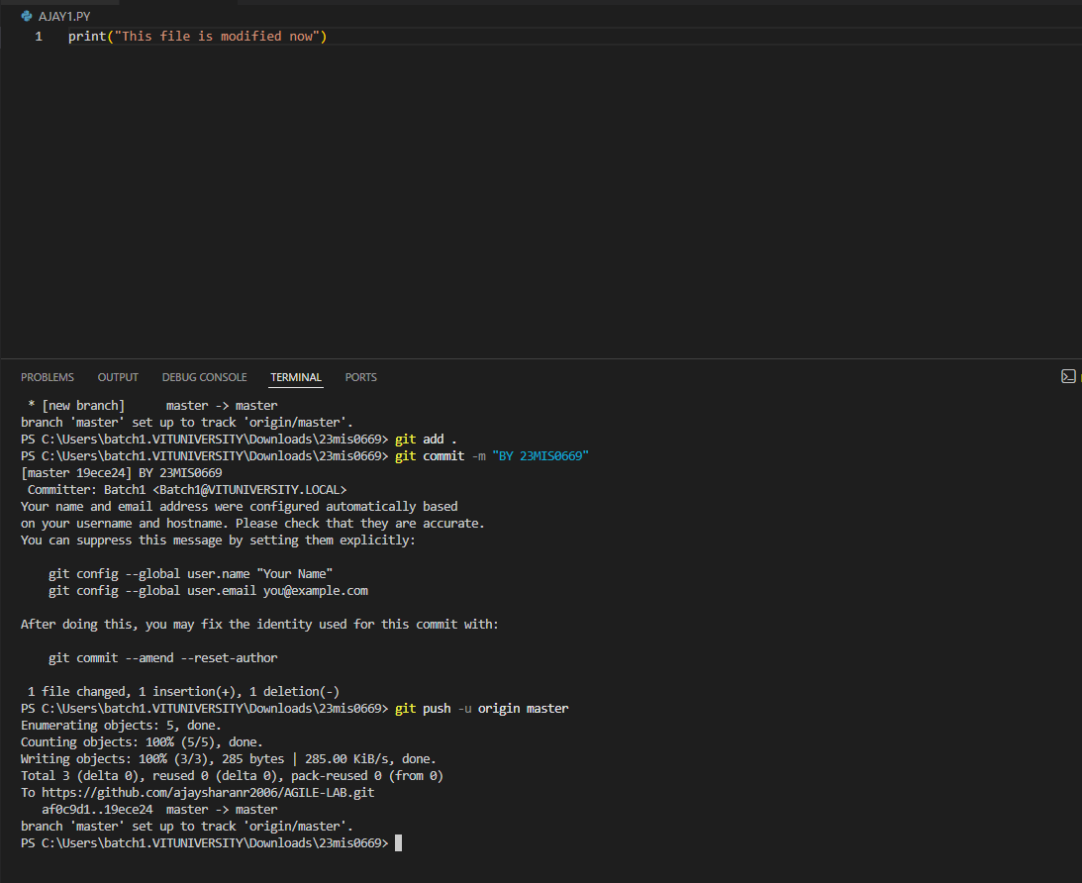

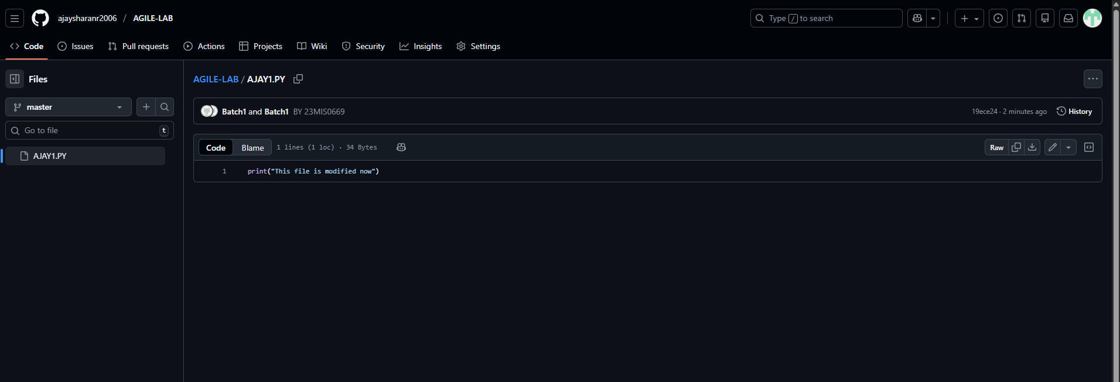

Case Study 3: Feature Development Using Branches

Scenario: A new Login feature must be developed without disturbing main code.

Tasks:

Create a new branch

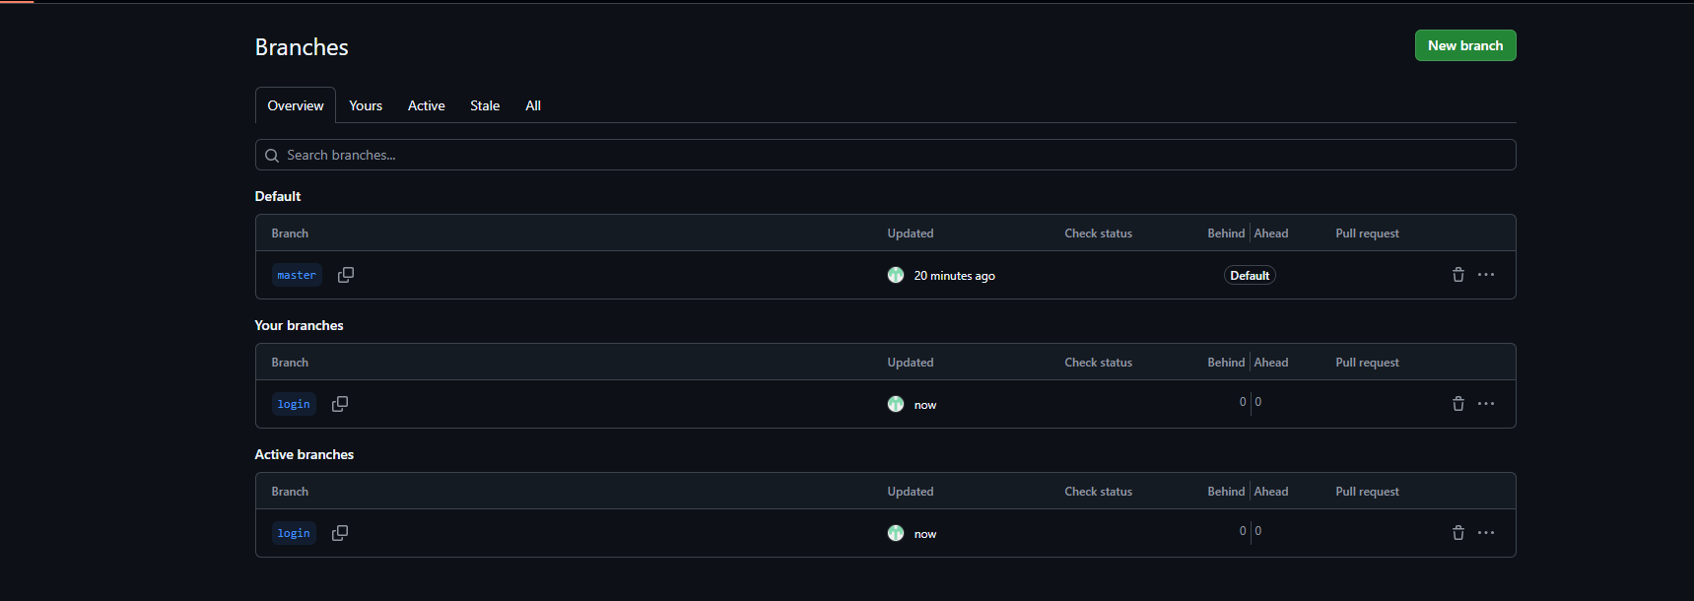

Add login-related code
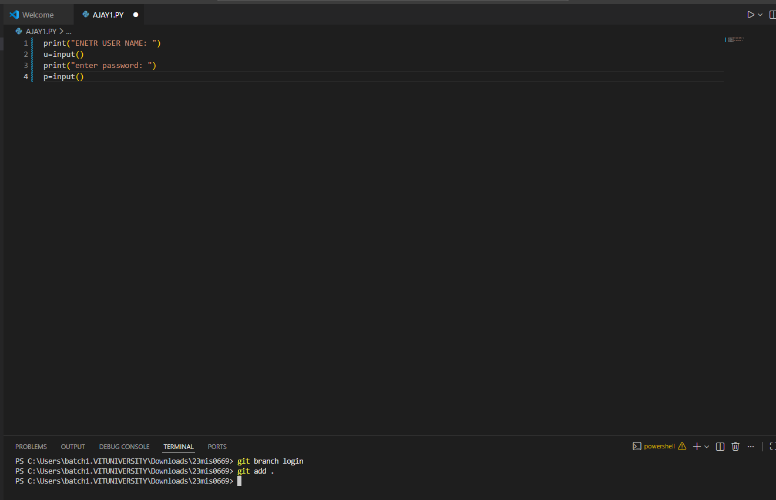

Commit changes
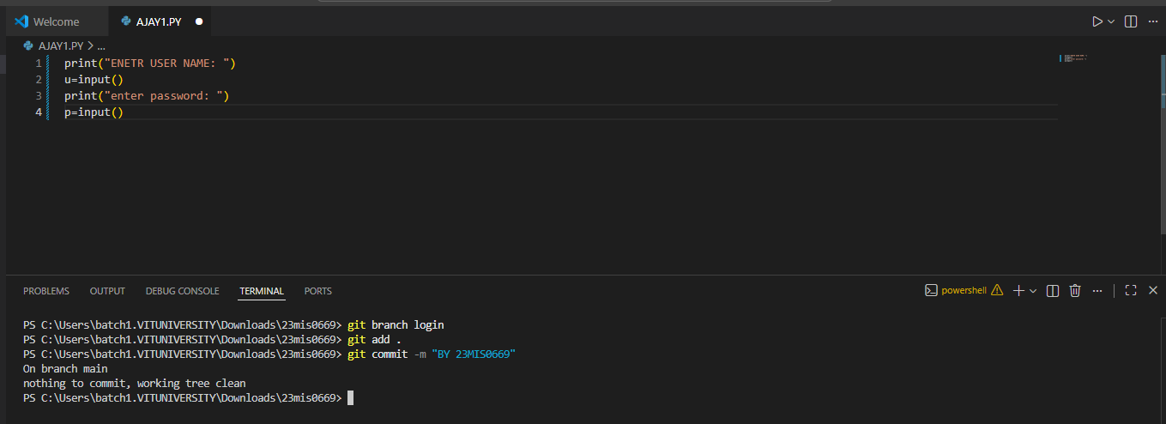

Switch between branches
